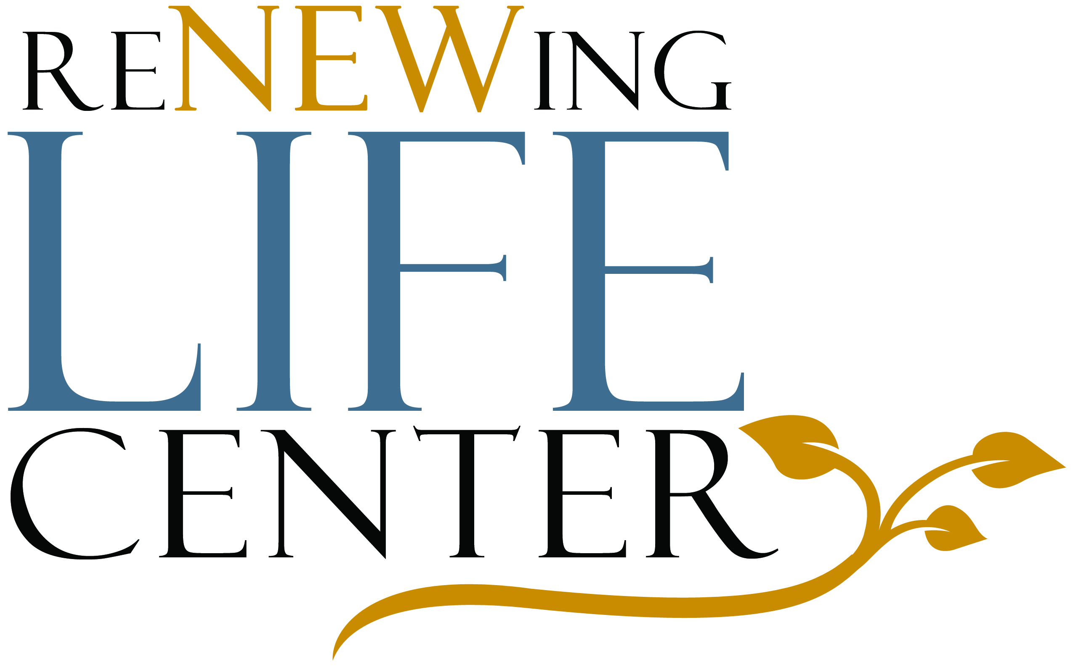
3243 E. Warm Springs Rd.
Suite 100
Las Vegas, NV 89120
(702) 434-7290

RELEASE OF INFORMATION

I, ________________________________________, hereby authorize the Renewing Life

Center to release all information pertaining to my evaluation and/or counseling sessions

to:_____________________________________________________________________

_______________________________________________________________________

_______________________________________________________________________

for the purpose of:________________________________________________________
(indicate the specific reason)

_______________________________________________________________________

I understand that authorization shall remain valid from the date of my signature below

and for twelve (12) months thereafter ending on:________________________________

I understand that my records are protected under Federal and specific State confidentiality laws and cannot be disclosed without my written consent unless otherwise provided for in the regulations. I also understand that I may revoke this consent at any time except to the extent that action has already occurred. I further acknowledge that the information to be released was fully explained to me and this consent given of my own free will.

_____________________________________________ ________________________
(Client, parent, guardian, or other authorized person to sign) Date

_____________________________________________ ________________________
(Client, parent, guardian, or other authorized person to sign) Date

